Game Design Document
Synthetic Schmup

Table des matières
1. Introduction 2
1.1 Scope 2
1.2 Target System 2
1.3 Development tools 2
2. Specification 2
2.1 Concept 2
2.2 Target player/Game feel expected 2
2.3 Story 2
3. Gameplay 3
3.1 Sum Up 3
3.2 Player Ship 3
3.2.1 Capacities available 3
3.2.2 Controls 3
3.3 Ennemies 4
3.4 Object and collectibles 4
3.4.1 Artifacts 4
3.4.2 Upgrades 4
3.4.3 Bonus items 4
3.5. HUD and interface 4
3.6. Levels 4
3.6.1. Level mapping 4
3.6.2. Kind of levels 4
3.6.3.Finishing a Level 5
4. Game Architecture 6
Logigram 6
#1 Main Menu 6
#2 Ship Selection 6
#3 Artifacts Mounting 6
#4 Game 7
#5 End 7
#6 Credits 7
#7 Settings 7

1. Introduction
This document specifies a design for the gameplay of a game with the project name "Synthetic Schmup".

1.1 Scope
This document is intended to be read by all the project team (programmers, artists etc) involved in the game production.

1.2 Target System
"Synthetic Schmup" will be produced for the following platform : PC Windows 10, PC Linux, Mac by priority level.

"Android?"

1.3 Development tools
The game will be develop on Linux Ubuntu based systems (Ubuntu, Mint, ...).
The EDI used is Qt Creator with the following configuration (Builder with version,).
The graphical aspect of the game will be produced with the SFML library.

2. Specification

2.1 Concept
The game is constructed as a kind of Rogue-like shooter. It will be very hard to finish the game in a single trial.
With his space ship, the player will struggle on followed levels ending with multipath choice.

After each tries/deaths, the player could equip his ship with the previously permanantly won items in order to go further in the game.

2.2 Target player/Game feel expected
The game is intended to reach hardcore gamers waiting for "gratifiant" games (cf "Dark Souls" franchise).

2.3 Story
Because the game is structured with multiple road, there will be a multiple ending story. This story will "encourage" the player to re-do the game several time (~8 ends).
---> Bonne rejouabilité

3. Gameplay

3.1 Sum Up
The game is constructed as a kind of Rogue-like shooter. It will be very hard to finish the game in a single trial :
- Each time the player will perform some particular actions (ex : defeat bosses, kill a special pattern of ennemies, finding a secret etc), some "Artifacts" will be unlocked
- When the player is defeated, he can relaunch a game from the very beggining but he can equip
- The multiple road choice is great for the following aspects :
  - It improves the "rejouabilité"
  - The player won't be disgusted by the hard difficulty because, if he dies at a level, he could choose another one
  - It can be a way to design a family of enemies and bosses (each level will come with some particular graphisms)
  - It can be a way to improve story telling

3.2 Player Ship

3.2.1 Capacities available
The action possible actions for the player are the following :
- Main capacities
  - Move in a 2D space (top point-of-view)
  - automatic rapid fire
- Artifact linked capacities
  - shield
  - allies
  - bombs
  - short invulnerability
  - etc

3.2.2 Controls
We must support the following controller (most important to less important):
- Keyboard
- Dualshock 4
- Xbox One Controller
- Xbox 360 Controller
The controls must be chosen carefully by default for each controller. The user can customize these controls.

3.3 Ennemies
A great number of ennemies must be present at the same time on the screen. To avoid the big mess it could be, the ennemies must attack with very specific geometric bursts (right, diagonal, circle).
Ennemies could be grouped by design families linked to specific level (Coherence between levels and ennemies).

3.4 Object and collectibles

3.4.1 Artifacts
Artifacts are ship's functionnalities improvements (wingman, shield, boost, teleport etc) that can be set up on a basic ship at the beginning of a trial.
It's collectible on a specific way (story reason, special goals etc).

3.4.2 Upgrades
Upgrades are ship's improvements that improve the functionnalities of a ship (HP, shield capacity, speed, number of wingman, boost recharge etc). It can improve the basic functionnalities of a ship or the Artifacts functionnalities.
It's collectible as a prize of special skills of the player (ennemies killed, time without hit etc)

3.4.3 Bonus items
Bonus items are given to the player randomly after an ennemy is killed but the level played can have an effect on the occurence probality.

3.5. HUD and interface
HUD mustn't invade the space of game, maybe it can disappear when it's not stimulated (full life)

3.6. Levels

3.6.1. Level mapping
Levels are linked as a tree wich is unknown by the player.

3.6.2. Kind of levels
- Classic levels:
Levels are generated procedurlarly. It contains procedurlay generated waves of ennemies.
- Story level:
This level are totally controlled levels. It contains specific waves of ennemies, an event and a boss. These levels are reached if the player reach
- Bonus level
Special level offers a randomly generated artifact (only non-posseded one) at the end of level

3.6.3.Finishing a Level
Just as the game "Outrun" (https://en.wikipedia.org/wiki/Out_Run), the player can choose the following level by choosing the left or right way separated by a vertical limit.

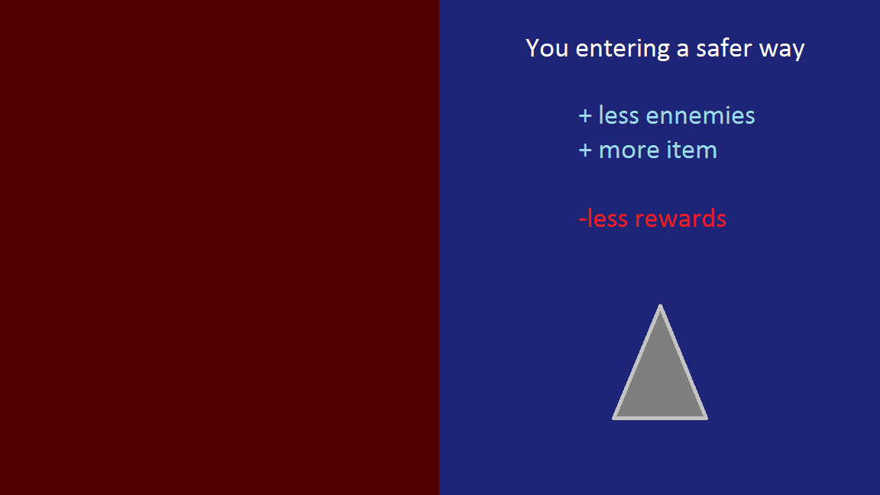

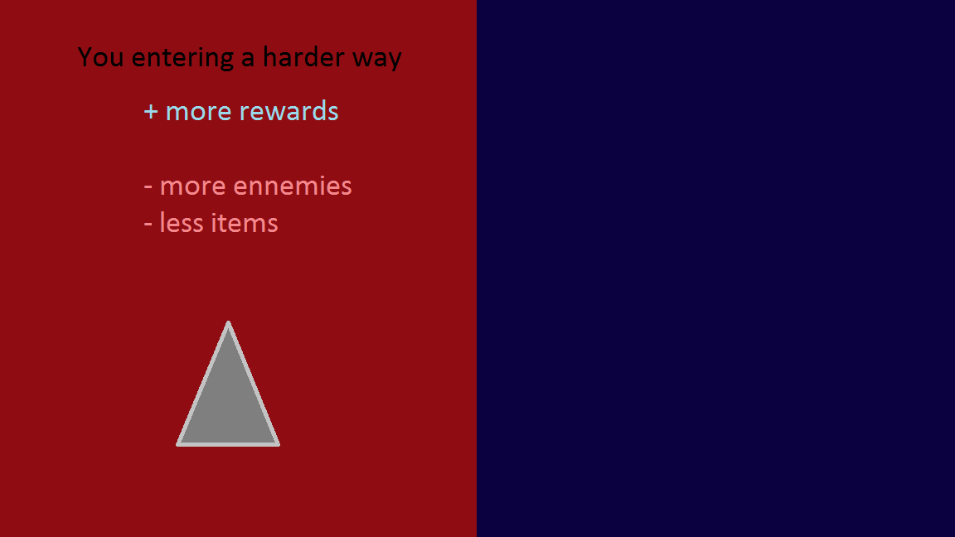

4. Game Architecture

Logigram

#1 Main Menu
Main Menu
Ship selection
Settings
Artifact Mounting
Game
Death
End
Credits
Pause
Quit
- Epic Menuying Flow : The menuying game flow must be very quick and pleasant: you must access the #4 just pressing the same button as an idiot.
- Music main theme (simple and memorable)
- Beautiful art (animated?)

#2 Ship Selection
- According to the "Epic Menuying Flow", a ship must be preselected. We can be inspired by the main menuying of the Blizzard game Starcraft II : all the possibility appears on a line, the first item is preselected but you can access the other items just by moving on it and select them (no return button).

#3 Artifacts Mounting
- According to the "Epic Game Flow", a set of artifact must be preselected. We can be inspired by the main menuying of the Blizzard game Starcraft II : all the possibility appears on a line, the set of item is preselected but you can access the other items just by moving on it and select them (no return button).
- Think about register some set of Artifacts to quickly prepare a ship.
- Artifacts must be secret : they are hidden until you unlocked after some sessions of gaming (as in Rogue Legacy).

#4 Game
- The player must destroyed the waves of ennemies in a vertical classic schmup game.
- Bosses or special events will be encountered during this "peaceful" journey.
- Multiple road choice
- Specific color for each level linked to a specific music tuning (cf synesthesia : https://en.wikipedia.org/wiki/Synesthesia)
- A memorable defeat mini music must be used to remember this awesome moment (cf Dark Souls, Abe Odyssee etc)

#5 End
A very memorable ending will wait for the player ! (Big boss, Multiple form boss, Ending twist...)

#6 Credits
- Time to show yourself guys !
- Can be dynamic by shooting on names for example (secret artifact for killing us all?)

#7 Settings
My favorite menu !
Customizable :
- sounds level (effects, musics, speeches?)
- definition
- Controller buttons
- render effects bonus

